FINAL REPORT - TEAM C
SPARK: AI Video Tagging Feasibility Study
Rachakonda Srikanth, Kunal Ghosh, Rex Brown
Sharon White, Ashley Jacobs, Alan Hernandez

EXECUTIVE SUMMARY
PReP International engaged Team C to assess the feasibility of “Project Spark,” an AI-driven video-tagging platform intended to transform career exploration through automated analysis of short career-story videos. The partner’s core hypothesis was that AI-generated motivational metadata, derived from video interviews and day-in-the-life recordings, could create a novel, analytics-based product to help employers predict candidate fit and reduce turnover. The team conducted a comprehensive evaluation across business viability, technical feasibility, and ethical and policy implications.
Our assessment confirms that while the underlying AI architecture is technically feasible using commercial cloud tools such as Google Video Intelligence, the broader business and regulatory environment renders the proposed analytics platform non-viable. The business analysis identified critical adoption barriers within the energy and utility sectors, including unproven ROI attribution, restrictive regulatory frameworks governing AI in hiring, and dependence on rights-restricted data. Additionally, YouTube platform constraints significantly limit the value of automated metadata for content discovery, undermining the economic justification for the model. Ethical risks, including bias amplification, privacy concerns, and content governance obligations, further increase implementation complexity and liability exposure.
The technical feasibility work demonstrated that video ingestion, transcription, embedding-based semantic tagging, and human-in-the-loop moderation can be reliably executed at low per-video cost. However, these capabilities do not overcome the structural business challenges, nor do they meaningfully enhance public-platform content visibility due to YouTube’s deprioritization of tags. As a result, the proposed product lacks a defensible market position and presents a high-risk, low-return strategic profile.
Based on the evidence, the team recommends a strategic NO-GO for the AI analytics platform and proposes a pivot to the Spark Career Content Library, a lower-risk, market-validated alternative aligned with PReP’s mission. This model emphasizes owned, high-quality career-story video production and licensing to workforce boards, employers, and education systems. It mitigates regulatory exposure, addresses a documented market gap in authentic career content, and allows PReP to build a scalable, defensible asset library.
This report provides the full rationale behind the recommendation, including business analysis, technical architecture, ethical considerations, and a forward-looking implementation path. Together, these findings position PReP to advance a mission-aligned, commercially viable strategy that supports workforce readiness through compelling, human-centered storytelling.

Project Background & Problem Statement
Partner Background
- Overview of PReP Intl. PReP International (PReP Intl.) is a career guidance and workforce development organization dedicated to tackling the global crisis of career disengagement. The organization operates on the premise that traditional career placement methods, which focus primarily on skills and experience fail to address the emotional and motivational drivers that lead to long-term professional fulfillment.
- Mission PReP Intl.’s mission centers on helping individuals discover genuine career fit by connecting them with the "why" behind a profession. The organization seeks to move beyond static job descriptions to provide tools that help candidates emotionally connect with real-world career narratives.

- Current Gaps in Career Exploration Platforms The current market for career exploration is fragmented. Workforce systems, community colleges, and employers often rely on static brochures, outdated web pages, or one-off videos of inconsistent quality to communicate career pathways. While platforms exist for skills assessment and labor market data, there is a distinct gap in tools that measure "intrinsic motivation" or help candidates visualize themselves in technical roles. PReP Intl. identified an opportunity to fill this gap by leveraging video content to capture these emotional signals.

Problem Statement
- The Core Problem PReP Intl. addresses the massive economic and social burden of workforce disengagement. Research indicates that over 70% of workers report feeling unengaged in their roles. In the United States alone, disengaged or actively disengaged employees contribute to an estimated $1.9 trillion in lost productivity annually. For employers, particularly in high-demand technical sectors like Energy, this manifests as high turnover rates and significant replacement costs.
- Insights from Stakeholder Meetings & Red Team Review Initial stakeholder engagements highlighted that traditional hiring tools cannot effectively measure a candidate's motivation or cultural fit prior to hiring. However, during the project’s "Red Team" review, a critical distinction was made between the problem (high turnover and lack of motivation data) and the partner's proposed solution (AI video tagging). The stakeholder hypothesis was that an AI-driven solution could transform professional video content into a monetizable B2B data asset—referred to as "Ponds of Talent" (PoTs), to predict retention.

- Why AI Video Tagging was Explored The "Project Spark" initiative was launched to investigate if Artificial Intelligence (AI) could automate the extraction of motivational metadata from career videos. The strategic hypothesis was that by tagging videos with RIASEC codes (Realistic, Investigative, Artistic, Social, Enterprising, Conventional), PReP could create a scalable "recommendation engine" for careers, similar to how consumer platforms recommend entertainment. This offered a potential opportunity to demonstrate the feasibility of a system that matches candidates to careers based on emotional resonance rather than just keywords

End User Profiles
- Career Explorers (Students & Job Seekers): Individuals, often in transition (e.g., students, veterans), who are struggling to find careers that align with their interests. They require authentic, "day-in-the-life" content to visualize themselves in specific roles.
- The "Risk-Averse Energy HR Executive" (B2B Customer): Represented by CHROs or VPs of Talent Acquisition at mid-to-large utility companies (1,000+ employees). Their primary goals are reducing turnover (currently 7-9%) and filling technical roles like linemen and engineers. They are conservative buyers who require proven ROI and strict regulatory compliance.
- PReP International Administrators: Internal users who would utilize the system to ingest, manage, and tag the library of video assets for distribution

Scope Definition
To ensure a focused feasibility assessment, the project scope was strictly defined as follows:
In Scope:
- Feasibility Assessment: Validating the "Ponds of Talent" monetization strategy across the broader U.S. market, with a specific validation case in the energy sector.
- Technical Architecture: Defining a conceptual AI architecture for processing videos, including ingestion, transcription, and RIASEC-based tagging, along with cost estimates.
- Ethical Framework: Establishing a governance framework to analyze risks related to bias, privacy, and consent, aligned with industry standards.

Out of Scope:
- Primary Research: No user surveys or interviews were conducted; analysis relied on secondary research.
- Software Development: The project did not involve coding, software development, or training custom AI models.
- Content Creation: No new video content was collected or filmed.
- Prototyping: No functional or working prototype was built

Success Criteria
The project’s success was defined by the delivery of a clear, evidence-based "go/no-go" recommendation to PReP Intl.. The specific criteria for this decision included:
- Business Viability: The ability to provide a data-backed narrative regarding market fit, specifically proving whether the "video tagging" solution could generate a sustainable ROI and defensible business case.
- Technical Feasibility: The delivery of a realistic technical blueprint that provides clear cost estimates and identifies the resource requirements for building a proprietary AI-driven platform.
- Ethical Alignment: The development of a framework ensuring the future platform could be trustworthy, legally compliant, and aligned with the NIST AI Risk Management Framework (RMF) to protect users from harm

Business Viability
SWOT Analysis
- Strengths: Addresses a massive financial pain point; theoretically differentiated.
- Weaknesses: Unproven ROI; reliance on rights-restricted data; high operational costs.
- Opportunities: Expansion to other sectors if attribution is proven.
- Threats: Regulatory intervention (AI bias laws); incumbents replicating features.

Competitive Landscape & Market Sizing Estimates
- Market Sizing (TAM/SAM/SOM)
- Total Addressable Market (TAM): The global HR technology market is valued at $42.5 billion (2025), with the AI video assessment sub-market exceeding $1 billion (25% CAGR).

- Serviceable Addressable Market (SAM): The energy sector spends over $10 billion on HR technology. We estimate a $500 million SAM for specialized "Spark Analytics" tools.

- Serviceable Obtainable Market (SOM): Targeting PReP’s network of 1,200+ placements offers an initial path, but capture is limited by high adoption barriers.

- Competitive Landscape.
- The market is saturated with incumbents who possess stronger data moats.

- Direct Competitors: HireVue and Spark Hire dominate the video interview space ($487M market).

Customer Persona & Value Proposition Definition
Customer Persona: "The Risk-Averse Energy HR Executive"
- Role: CHRO or VP of Talent Acquisition at a mid-to-large utility (1,000+ employees).

- Goals: Reduce turnover (currently 7-9%), fill technical roles (linemen, engineers), and meet DEI targets.

- Pain Points: High cost of replacement ($7.6M/year), safety risks from inexperienced hires, and strict regulatory compliance needs.

- Buying Behavior: Extremely conservative. Requires proven ROI and zero regulatory liability before adoption.
ROI Projections (Initial Rough Estimate)
  - ROI Assumptions Lack Real Proof The projected ROI (20x–70x) is built on "heroic" assumptions of 5–15% attrition reduction.

  - The Investment: High fixed costs for development ($50k MVP), high CAC (paid ads vs. viral), and ongoing compliance audits.

  - The Return: Theoretical savings of $500,000–$3 million annually per client.

  - However, because retention is multifactorial, attributing these savings to Spark Video is impossible, making contract renewals unlikely

Ethical & Policy Considerations
Mitigation Strategy (for the Pivot)
By shifting to a Content Library model (see Section 6), PReP removes the "AI Assessment" risk entirely. The product becomes a media asset, not a hiring filter, bypassing the strict regulations governing AI selection tools

High-Level Business Model Canvas (Evaluation of Current "No Go" State)
Below is the assessment of the proposed business model, highlighting the critical failures that lead to the "No Go" recommendation.
Component | Proposed Model (Spark Video) | Feasibility Assessment
Value Propositions | Predictive retention analytics via "Spark Moments." | Weak. Attribution is unproven; perceived value is lower than regulatory risk.
Customer Segments | Energy Utilities, Trade Schools, Associations. | Misaligned. Energy sector is too risk-averse for early-stage AI adoption.
Channels | Direct Sales, PReP Network, Viral Growth. | Failed. Viral growth is technically infeasible due to YouTube algorithms.
Revenue Streams | B2B Subscriptions ($10k-$50k/yr). | Unstable. Long sales cycles (12-18 months) delay revenue beyond startup survival.
Key Resources | AI Algorithms, Curated Video Dataset. | Lacking. No proprietary dataset exists; AI is a commodity
Key Activities | AI Tagging, Video Moderation. | Not Scalable. Human-in-the-loop moderation destroys SaaS margins

Results & Evaluation: The Case Against Spark Video

ROI Assumptions Lack Real Proof
The projected ROI (20x–70x) is built on "heroic" assumptions of 5–15% attrition reduction. These figures are derived from broad industry studies (Gallup, McKinsey) rather than specific Spark Video pilots. Retention is multifactorial (influenced by pay, culture, leadership), making it nearly impossible to attribute improvements solely to this tool. Without statistically valid pilot data, the ROI collapses.

Weak Defensibility & Competitive Landscape
Spark Video’s "motivational video dataset" is not a sustainable moat (one of a kind & proprietary). Direct competitive incumbents like Workday, Oracle, and LinkedIn already control the hiring ecosystem. They possess the data infrastructure to replicate video tagging features immediately. Spark Video risks being a "feature, not a product."

Adoption Barriers in Conservative Industries
The target market (Energy) is compliance-heavy. Introducing video-based AI assessments triggers immediate concerns regarding privacy and fairness. Risk-averse HR leaders are unlikely to be early adopters of a tool that adds regulatory exposure without proven attribution.

Operational Costs Undercut SaaS Economics
Maintaining a high-quality "Pond of Talent" requires human moderation to validate AI tags and mitigate bias. This transforms the business model from a high-margin SaaS platform into a labor-intensive human-in-the-loop service business, severely limiting scalability.

Recommendations & Next Steps

Strategic Decision: NO GO
The feasibility analysis suggests that Spark Video is not a sustainable long-term business in its current form. The risks of pursuing the original "viral, public-data" concept outweigh the potential returns.

The Pivot
We recommend PReP International pivot immediately from AI Analytics to Content Ownership.

New Solution: The Spark Career Content Library. A professionally produced, curated video library of career stories licensed to schools, workforce boards, and employers.

The feasibility analysis confirms that Spark Video as an AI platform is a high-risk, low-viability venture due to regulatory hurdles and unproven ROI. However, the market demand for career pathway content is real. By pivoting to the Spark Career Content Library, PReP International can build a sustainable, defensible business that aligns with its mission and generates immediate revenue without the existential risks of AI governance.

For more detailed information on this specific recommendation, See Appendix B.

System Design and Technical Architecture
System Architecture Overview
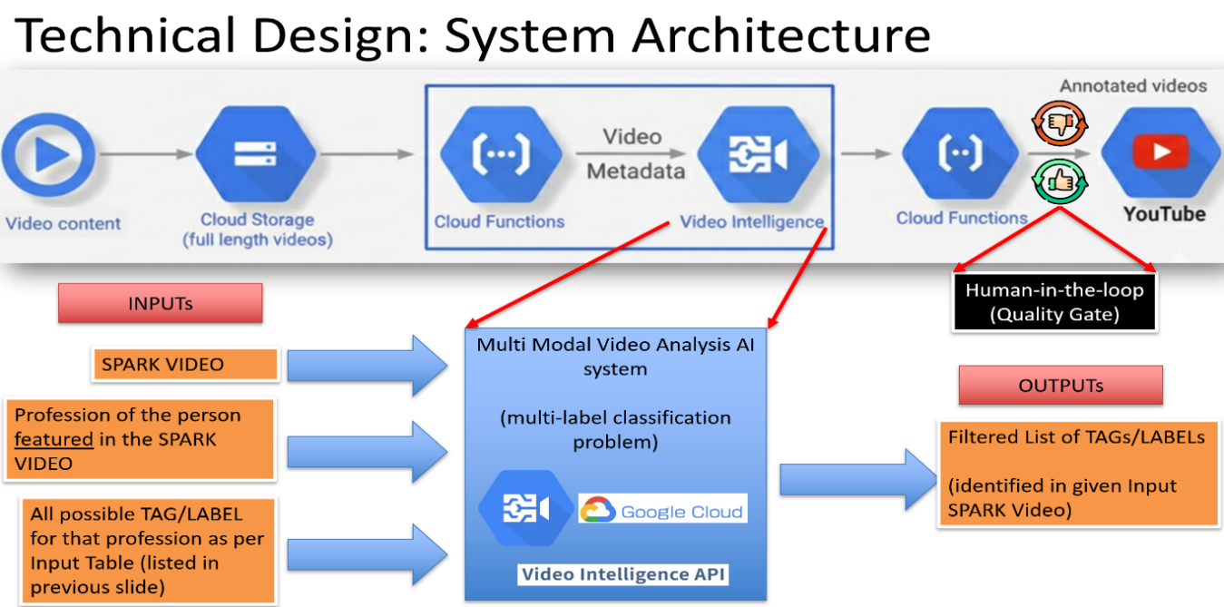
The proposed technical solution, as shown in the Fig. 1 below, utilizes a cloud-native, multi-modal architecture designed to automate the generation of metadata tags for "Spark Videos"—short-form visual assets dedicated to career exploration. This system integrates video ingestion protocols, AI-driven content analysis, and a structured tagging taxonomy to significantly enhance content discoverability on digital platforms, specifically YouTube.
Figure 1: System Architecture
Architectural Workflow
The system workflow adheres to a linear pipeline methodology, augmented by a mandatory feedback loop to ensure rigorous quality assurance:
- Ingestion and Acquisition of Video Assets:
  - The process initiates with the ingestion of Video Content, specifically designated "Spark Videos"—brief, engaging visual narratives designed to illustrate specific professional roles.
  - Raw video files are uploaded to Cloud Storage, which serves as the centralized repository (data lake) for the archiving of full-length video content.
- Processing and Enrichment:
  - Cloud Functions serve as the primary event-driven orchestration layer. Upon the detection of a new file upload, a specific function triggers the analysis pipeline.
  - The core processing unit is the Video Intelligence API (Google Cloud) [1]. This component executes deep content analysis, extracting video metadata, visual labels, and audio transcriptions.
  - Simultaneously, the system assimilates contextual data, including the Profession of the individual featured in the video and a pre-defined registry of TAGS/LABELS associated with that profession, derived from the RIASEC model [2].
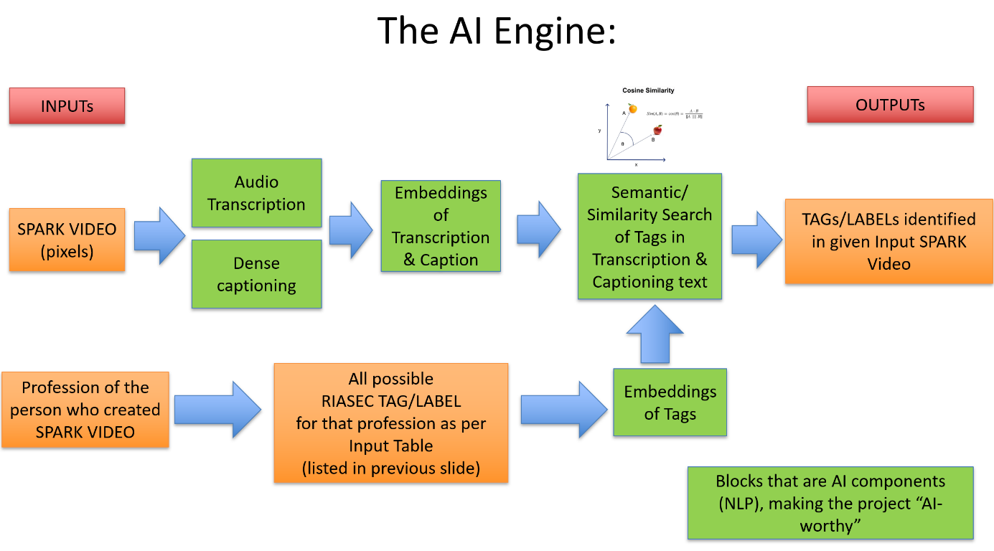
- The AI Engine (Multi-Modal Analysis):
Figure 2: The AI Engine

  - The architecture employs a Multi-Modal Video Analysis AI System, framed as a multi-label classification problem as shown in the Fig. 2. above.
  - Visual & Audio Inputs: The system processes video pixels to generate dense captioning while concurrently transcribing the audio track.
  - Embedding Generation: Both the video content (encompassing transcriptions and captions) and the prospective tag list (derived from the RIASEC profession input) are converted into vector embeddings.
  - Semantic Matching: The engine performs a semantic similarity search utilizing Cosine Similarity to align the video content with the dictionary of profession-specific tags. This procedure ensures that generated tags are not merely generic keywords but are contextually aligned with the specific career depicted.
- Output and Quality Assurance:
  - The AI produces a filtered enumeration of tags and labels detected within the input video.
  - Human-in-the-Loop Protocol: Prior to final publication, a manual quality gate is implemented. This step mandates that human adjudicators validate (approve) or reject the suggested tags, thereby ensuring high precision and mitigating the risk of non-compliant or excessive tagging that could violate platform policies.
  - Final Destination: The verified, annotated videos and their associated metadata are subsequently published to YouTube.
Technical Components
The system architecture is underpinned by a comprehensive suite of enterprise-grade cloud services and specialized algorithmic methodologies designed to ensure both scalability and accuracy.
Tools Evaluated and Selected
- Google Cloud Platform (GCP): Selected as the primary infrastructure provider due to its superior video analysis capabilities.
  - Cloud Storage: Utilized for the secure and scalable object storage of raw video assets.
  - Cloud Functions: Serverless compute units employed to integrate services, effectively minimizing idle costs.
  - Video Intelligence API: The core AI service utilized for label detection, shot change detection, and transcription. This service was selected over the development of custom models to expedite deployment and leverage pre-trained, state-of-the-art computer vision models.
- YouTube Data API: Employed for the final phase of uploading videos and inserting the generated tags into the video details.
- Generative AI & NLP: The system utilizes Natural Language Processing (NLP) techniques to generate embeddings (vector representations of text), bridging the semantic gap between visual content descriptions and standardized career terminology.
Tagging Schema and Metadata Structure
The metadata structure is grounded in the RIASEC model (Realistic, Investigative, Artistic, Social, Enterprising, Conventional), a standardized framework for career counselling.
- Input Mapping: Each video is associated with a specific Standard Occupational Classification (SOC) code via O*NET data [3].
- Taxonomy: Tags are systematically derived from the "Interests" and "Work Activities" associated with a given occupation, ensuring relevance rather than randomization.
- Example Structure:
  - Role: Electrical Engineer
  - RIASEC Code: R-I-C (Realistic, Investigative, Conventional)
  - Generated Tags: "workshop," "lab bench," "wiring," "PPE," "power systems," "control room."
Cost Analysis for Video Processing
A detailed unit economics analysis, as shown in the Fig 3 below, was conducted to assess the financial viability of scaling this solution.
- Storage Costs: Assessed as negligible, estimated at approximately $0.0002 per video for data at rest [4].
- Compute Costs: Cloud Functions invocations are minimal per video (approximately $0.0000008) [5].
- AI API Costs: The primary cost driver identified is the Video Intelligence API, which incurs a charge of $0.10 per minute of video processed [6].
- Total Unit Cost: For a standardized 7-minute Spark Video, the processing cost is approximately $0.70.
- Contingency: Applying a conservative contingency multiplier of 2.0x, the estimated cost is $1.40 per 7-minute video. This low unit cost suggests high economic viability for the processing of extensive content libraries.

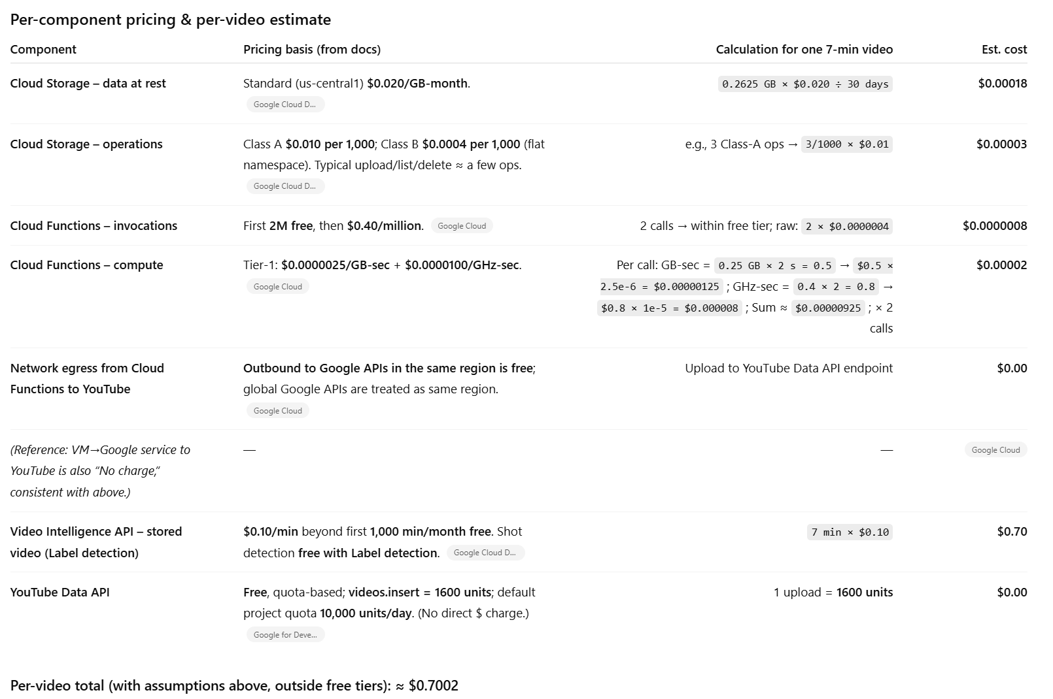
Figure 3: The detailed Unit Cost Calculation

Cost Exclusions
The aforementioned unit economics strictly pertain to the metadata generation and technical processing pipeline. The following cost centers are explicitly excluded from this analysis:
- Video Production: Costs associated with filming, editing, and producing the "Spark Videos."
- Intellectual Property Clearance: Legal fees required to secure rights for third-party footage or audio.
- Human Review: Labor costs for the "Human-in-the-Loop" quality assurance step.
- Platform Fees: Any potential costs associated with YouTube channel management or promotion.
- Platform Development: Cost of this video-tagging platform development and maintenance.
Data Strategy
The data strategy emphasizes the acquisition of high-quality, standardized occupational data, as shown in the Table 1 below, to train the matching engine and populate the tag dictionaries.
Profession / Role  (Input 1) | PReP Intl Job Openings | Mapped O*NET Occupation | Top RIASEC Interests | 3-Letter Code | List of SPARK Video Tags/Labels  (Input 2)
Electrical Engineers | https://pros.prepintl.com/Sr-EE-GWP | 17-2071.00  www.onetonline.org/link/details/17-2071.00 | Realistic (89),  Investigative (72),  Conventional (67) | R-I-C | workshop/lab bench, wiring, PPE, power systems, control room, substation yard, “day-in-the-life”, certifications
Waste Water Facility Principal Engineer | https://pros.prepintl.com/WFPE-SJ | 51-8031.00  www.onetonline.org/link/details/51-8031.00 | Realistic (97),  Conventional (61),  Investigative (29) | R-C-I | plant galleries, clarifiers, control room screens, maintenance walk-throughs, licensing/cert tracks, PPE, “day-in-the-life”, certifications overview
Project Management Specialists | http://pros.prepintl.com/PM-ROW-OTX | 13-1082.00  https://www.onetonline.org/link/details/13-1082.00 | Enterprising (89), Conventional (76), Social (39) | E-C-S | planning & scheduling, risk/issue management, budgeting, change control, WBS, Gantt, RAID, PMBOK/Agile, certifications
Table 1: Sample Input Data for Training of AI Model

Required Data Inputs
- Spark Videos: Raw MP4 files depicting various "Day in the Life" career scenarios.
- PReP Intl. Job Openings: Real-world job opening data utilized to identify high-demand roles [7].
- O*NET Database: The primary source for occupational definitions. O*NET web services are utilized to retrieve detailed descriptions, tool usage, and work contexts for specific job codes (e.g., 17-2071.00 for Electrical Engineers).
Data Preprocessing Protocols
- Mapping: Job openings are systematically mapped to O*NET occupation codes.
- RIASEC Scoring: For each occupation, the top three RIASEC interest areas are identified (e.g., Waste Water Engineers are classified as R-C-I).
- Tag Extraction: Relevant keywords are extracted from the O*NET descriptions corresponding to the RIASEC codes. These keywords constitute the "Ground Truth" list of tags for the AI to locate within the video.
Data Integrity Risks and Mitigation
- O*NET Limitations: While comprehensive, O*NET descriptions may occasionally appear theoretical or archaic relative to contemporary industry terminology [8].
- Video Fidelity: In instances where the Spark Video is poorly lit or the audio clarity is compromised, the Transcription and Dense Captioning modules may fail to generate accurate embeddings, resulting in missed tags (false negatives).
Methodology
Feasibility Assessment Methodology
The feasibility study was conducted in three distinct phases:
- Technical Feasibility: Validation of whether commercial-off-the-shelf (COTS) AI tools (Google Video Intelligence [1]) could accurately identify specific career-related objects (e.g., distinguishing a "clarifier" in a wastewater plant from a generic "pool").
- Economic Feasibility: Calculation of unit economics to ensure the cost per video does not exceed the business value derived from the generated tags.
- Compliance Feasibility: Analysis of the target platform's (YouTube) Terms of Service regarding automated metadata and tagging.
Conceptual Workstreams and Evaluation Logic
- Pipeline Development: A conceptual pipeline was architected to connect Cloud Storage to the Video Intelligence API.
- Embedding Test: Cosine similarity tests are included to compare the "distance" between video captions and target tags. A threshold is established to filter out weak matches.
- Human Evaluation: A "Quality Gate" was introduced. The evaluation logic dictates that AI-suggested tags must be verified by a human subject matter expert prior to commitment to the public platform. This hybrid approach mitigates the risk of AI hallucinations.
Key Technical Justifications
Justification for Architectural Viability
- Scalability: The serverless architecture (Cloud Functions) ensures the system can accommodate volumes ranging from a single video to 1,000 concurrent uploads without the need for manual provisioning [9].
- Modularity: Decoupling the storage, processing, and logic layers allows individual components (such as the AI model) to be upgraded without necessitating a comprehensive system reconstruction.
- Contextual Awareness: By injecting the "Profession" as an explicit input, the system narrows the search space. It does not merely search for "objects," but rather for "objects expected within an Electrical Engineering context," thereby significantly increasing precision.
Trade-offs
- Accuracy vs. Automation: Fully automated tagging was deemed excessively risky due to spam policies [10]. The selected trade-off was a Human-in-the-Loop system. While this increases operational effort (manual review), it guarantees compliance and high data quality.
- General vs. Custom Models: Utilizing the pre-trained Video Intelligence API is more cost-effective and expeditious than training a custom Computer Vision model, although it may face challenges with highly niche industry equipment. This trade-off is accepted by relying on text embeddings (OCR and Audio) to supplement visual recognition.
Constraints
- Platform Dependency: The system is entirely dependent on Google Cloud and YouTube APIs. Any deprecation of these services would necessitate a major refactoring effort.
- Tagging Limits: YouTube restricts tags to 500 characters [11]. Consequently, the system logic must prioritize the highest-confidence tags to adhere to this constraint.

Results & Evaluation
Business Impact Analysis
TAM/SAM/SOM Summary
The target market for this technology encompasses career counselling platforms, educational institutions, and workforce development agencies. The Serviceable Addressable Market (SAM) is defined by the number of unique "Spark Videos" required to cover the approximately 1,000 distinct occupations listed in O*NET.
ROI Projections and Critical Risks
- Cost Efficiency: The projected cost of $1.40 per video is significantly lower than the manual labor cost required for a human to view a 7-minute video, research keywords, and manually input them (estimated at 15-20 minutes of labor).
- ROI Challenge: A critical finding during the evaluation is that YouTube's policy explicitly states: "Tags play a minimal role in your video's discovery" [10]. This challenges the fundamental return on investment for the project. If the tags do not drive significant view traffic, the business value of generating them—even at a low cost—is diminished.
- Strategic Realignment: The recommendation is to pivot the value proposition from "SEO/Discovery" to "Content Indexing" and "Internal Searchability" for a proprietary career video library, rather than relying solely on YouTube discovery mechanisms.
Technical Performance Evaluation
Scalability Assessment
The technical design has proven to be highly scalable. The utilization of cloud-native components ensures the system faces no hard limits on the volume of video processing, other than budgetary constraints.
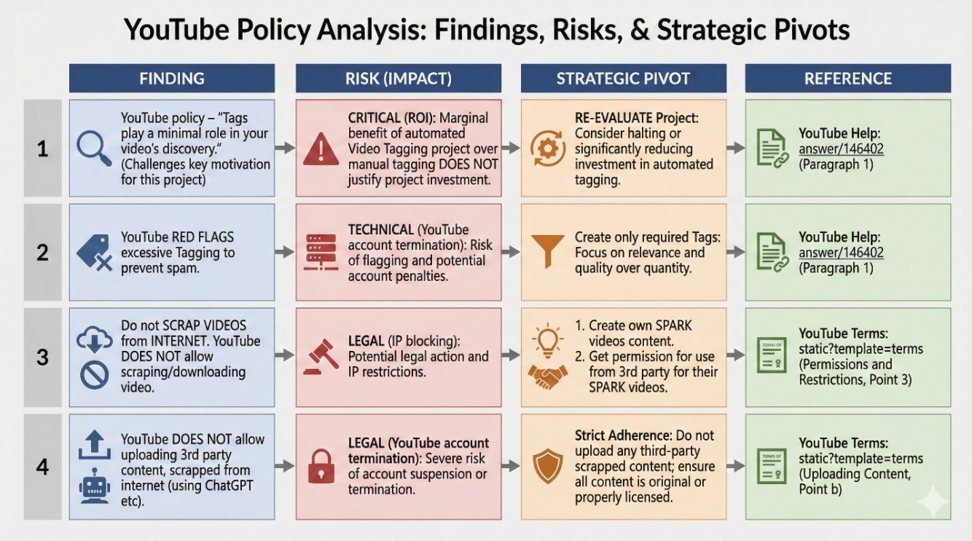

Figure 4: Summary of Risk
Limitations of YouTube as a Platform
Several findings, as shown in the Figure 4 above, identified during the technical deep dive pose significant hurdles:
- Policy on Tags: YouTube's algorithms identify excessive tagging as indicative of spam activity. This introduces a risk of account termination if the AI generates a surplus of tags [10].
  - Mitigation: The system must strictly limit output to the top 5-10 most relevant tags.
- Scraping Restrictions: The initial concept of scraping existing YouTube videos to build a training dataset is not viable. YouTube's Terms of Service (permissions and restrictions) strictly prohibit the scraping and downloading of videos [12].
  - Pivot: The project must rely strictly on "Spark Videos" created in-house or licensed from third parties, ensuring clear Intellectual Property (IP) rights.
Unit Cost of Spark Video
The financial model has been validated. At $1.40 per asset, the cost of processing is predictable. However, this cost only covers the metadata generation. It does not encompass the cost of video production or the potential legal costs associated with IP clearance.
Overall Feasibility
Consolidated Insights
The project is deemed Technically Feasible but carries High Business/Platform Risk.
- Strengths: The multi-modal AI approach (combining audio, text, and visuals) is robust and capable of generating high-quality, context-aware descriptive tags. The RIASEC integration provides a strong theoretical framework for the data.
- Weaknesses: The reliance on YouTube as the distribution mechanism represents the most significant vulnerability. YouTube's algorithms prioritize watch time and click-through rate over metadata tags, limiting the upside of this tool for public discovery [13].
- Assumptions: The model assumes that O*NET descriptions accurately reflect the visual content of a "Day in the Life" video. If the video is stylistic or abstract, the match rate will likely diminish.
Limitations
Resource Constraints
- Human Review Bandwidth: The "Human-in-the-Loop" component, while necessary for quality, becomes a bottleneck at scale. Processing 1,000 videos a day would necessitate significant human labor hours for approval.
Missing Data
- Niche Occupations: For emerging roles (e.g., "Prompt Engineer" or specific green tech jobs), O*NET data may be sparse or non-existent, leaving the system without a "Ground Truth" tag list.
Partner Dependencies
- API Quotas: The YouTube Data API imposes a daily quota (10,000 units/day) [14]. Uploading a video costs 1,600 units. This limits the system to uploading approximately 6 videos per day per project without requesting a quota increase from Google. This represents a critical throughput constraint for a commercial-scale deployment.
Legal and Compliance
- IP Blocking: Strict adherence to copyright laws is mandatory. The system cannot process or upload content that contains unlicensed third-party footage or audio, as this triggers YouTube's Content ID system and impedes publication.

Red Team Recommendation Response - Technical
“What the partner must understand about data rights, signal validity, and feasibility”
Included and addressed in Section 4.2 Scalability assessment.
“How different scenarios (minimal vs. larger scale) shape their investment choices”
Included and addressed in Section 3.2 Cost Analysis for Video Processing including contingency (for minimal vs larger scale)
Ethical Framework
Project Spark presents the following policy and ethical risks:
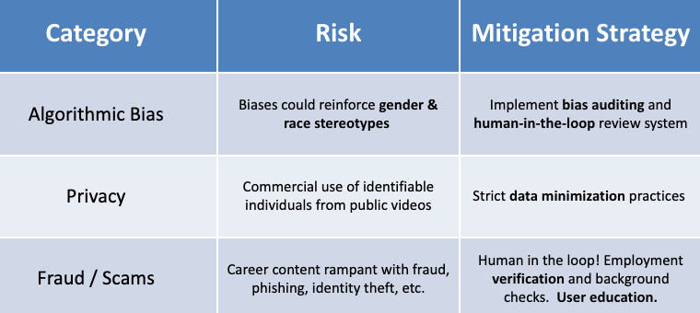
A career inspiration platform like Spark could potentially reflect and amplify historical societal biases and inequalities. For example, biased training data could cause Spark to recommend engineering jobs to male users and nursing or teaching jobs to female users, regardless of the student’s actual interests and skills.
The specific mitigation strategy to minimize and prevent algorithmic bias will depend on (1) what information Spark has about a specific user and (2) how that information is leveraged to serve specific types of content. However, Spark should adopt a "Fairness-by-Design" approach:
- Technical Mitigation: Spark should train its AI to give recommendations that are so neutral that it is impossible to guess the user's gender based on the results
- Policy Mitigation: Our team recommends that Spark consider adopting the NIST AI Risk Management Framework (AI RMF) to govern this process. This includes publishing an Algorithmic Impact Assessment (AIA) to provide transparency on how the model was tested for bias. Spark should look to experts and third-party entities who may be able to advise on best practices in this area, so that Spark doesn’t need to spend a lot of resources on this step. Our team received feedback during the red team stage that a small company may have difficulty following the full NIST RMF, which we agree with. The partner will need to balance the resource costs associated with the potential gains, and utilizing more manual approaches early on (e.g. human in the loop) may be effective in lieu of adopting a fully automated technical mitigation and framework.
Privacy is the second pillar of a strong policy foundation. Spark should leverage strict data minimization practices to ensure that user data is protected. Specifically, Spark should implement a "Separation of Concerns" architecture:
- Identity vs. Activity: Personally Identifiable Information (PII) like names and emails should be stored in a separate, access-controlled database from the "activity data" (clicks, likes, career interests) used to train the algorithm. This ensures the recommendation engine never "sees" the student's real identity, since these databases of information are siloed off from one another.
- Retention Policies: Spark must establish strict data retention schedules—e.g., automatically deleting user behavioral data after 12 months or immediately upon account closure—to respect user privacy and prevent "data hoarding" which increases security risks.
Lastly, Spark must proactively address the potential risk of fraudulent job postings, which are often used for phishing, identity theft, or financial fraud (e.g., fake check scams, requests for upfront payment). To protect its users from "too good to be true" offers—Spark must enforce stringent validation mechanisms. In the beginning, Spark could leverage manual human review of every uploaded video content but will need to leverage more scalable mitigation strategies as the platform grows and scales:
- Mandatory Verification: Spark could require video uploaders to verify a corporate email domain. Accounts using free email services (like Gmail) should be prohibited from posting jobs or flagged for immediate human review. Spark could even consider background checks in certain cases.
- Payment & Credential Screening: Spark should develop processes to identify video content that contains major red flags, such as requests for upfront payments (for training or equipment), bank account information, or personal passwords/credentials. This mitigation strategy would also apply to other product elements that Spark could add down the line, such as user comments or direct messages.
- Proactive Warnings: Spark could display periodic "scam warning" interstitials on its app/website, educating users about the signs of fraud (e.g., offers with unrealistic pay for minimal effort, refusal to do a video interview). Additionally, Spark’s marketing and communications teams could reinforce safety best practices consistently and often.

Spark can also protect users by publishing and operationalizing a content policy, the set of rules that define what is allowed or banned on the Spark platform. A clear content policy protects users, Spark's reputation and platform, ensures it complies with the law, and empowers the enforcement team to do their jobs.
Here are draft guidelines that the Spark team could choose to implement:
- Content uploaded to Spark must not contain:
  - Frauds/Scams: Fake job postings, predatory financial schemes, or content soliciting personal financial information.
  - Misinformation & Harmful Content: Demonstrably false advice or dangerous instructions.
  - Hate Speech & Discrimination: Content that promotes discrimination based on race, gender, religion, or other protected characteristics.
  - Copyright Infringement: Content that clearly violates the intellectual property rights of others.
Example Enforcement policy and operational procedures:
- Review Process: A hybrid model of automated keyword flagging followed by human review will be used to review complex cases.
- Actions: Violating content will be removed from the platform and excluded from AI training datasets to prevent the model from learning toxic patterns.
- Appeals: A mechanism for users to contest moderation decisions to ensure due process.
The level of effort required for Spark to enforce a content moderation policy will depend on factors such as turnaround time, service level agreement, language support, etc.
Recommendations & Next Steps
- Adding Tags on YouTube does not add to virality as per YouTube Policy. Hence, this AI based Video Tagging project could be discontinued.
- Identify policy & ethics risks early, and implement mitigation strategies (this will depend on ultimate technical implementation and use cases)
- Research on the nature of video content that increases virality.
- Pivot to Spark Video Content Library

Appendices
Appendix A
References
[1] Google Cloud. (n.d.). Video AI and intelligence. Retrieved from https://cloud.google.com/video-intelligence
[2] Holland, J. L. (1997). Making vocational choices: A theory of vocational personalities and work environments (3rd ed.). Psychological Assessment Resources.
[3] National Center for ONET Development. (n.d.). ONET 30.0 Database. Retrieved November 30, 2025, from https://www.onetcenter.org/database.html
[4] Google Cloud. (n.d.). Storage Pricing. Retrieved from https://cloud.google.com/storage/pricing
[5] Google Cloud. (n.d.). Cloud Functions Pricing. Retrieved from https://cloud.google.com/functions/pricing
[6] Google Cloud. (n.d.). Video Intelligence API Pricing. Retrieved from https://cloud.google.com/video-intelligence/pricing
[7] PReP Intl. (n.d.). Our Team. Retrieved from https://www.prepintl.com/our-team/
[8] Handel, M. J. (2016). The O*NET content model: Strengths and limitations. Journal for Labour Market Research, 49(2), 157-176.
[9] Google Cloud. (n.d.). Serverless: Fully managed, scalable, and secure. Retrieved from https://cloud.google.com/serverless
[10] Google. (n.d.). Add tags to videos. YouTube Help. Retrieved from https://support.google.com/youtube/answer/146402
[11] Promfly. (2025). How Many Tags Can You Use on YouTube? Best Practices & Limits. Retrieved from https://www.promfly.com/blogs/complete-guide-to-youtube-tags
[12] Google. (n.d.). Terms of Service. YouTube. Retrieved from https://www.youtube.com/static?template=terms
[13] Hootsuite. (2025). How the YouTube algorithm works in 2025. Retrieved from https://blog.hootsuite.com/youtube-algorithm/
[14] Google Developers. (n.d.). YouTube Data API Overview: Quota Usage. Retrieved from https://developers.google.com/youtube/v3/getting-started
Barclay, S. R., & Wolff, L. A. (2012). Exploring the career construction interview for vocational personality assessment. Journal of Vocational Behavior, 81(3), 370-377.
Creator Insider (Director). (2018, July 12). MYTHBUSTING #1: Are Tags Important? [Video]. YouTube.
De Smet, A., Hazan, E., & Ramaswamy, S. (2023). Some employees are destroying value, others are building it—do you know the difference? McKinsey & Company. https://www.mckinsey.com
Gallup. (2024). State of the Global Workplace: 2024 Report. Gallup. https://www.gallup.com
Gartner. (2024). Employee retention strategy and cost of turnover benchmarks. Gartner Research. https://www.gartner.com
Hoff, K. A., et al. (2024). Interested and employed? A national study of gender differences in basic interests and employment. Journal of Vocational Behavior, 148.
Kristof-Brown, A. L., Zimmerman, R. D., & Johnson, E. C. (2005). Consequences of individuals’ fit at work: A meta-analysis of person–job, person–organization, person–group, and person–supervisor fit. Personnel Psychology, 58(2), 281–342. https://doi.org/10.1111/j.1744-6570.2005.00672.x
Macready, H. (2025, February 15). How the YouTube algorithm works in 2025. Hootsuite.
National Institute of Standards and Technology. (2023). Artificial Intelligence Risk Management Framework (AI RMF 1.0). Retrieved from https://www.nist.gov/itl/ai-risk-management-framework
S&P Global Sustainable1. (2024). Prioritizing employee wellbeing may help stem the tide of rising turnover. S&P Global. https://www.spglobal.com
Society for Human Resource Management (SHRM). (n.d.). Turnover cost calculation spreadsheet. SHRM. https://www.shrm.org
U.S. Department of Energy. (2023). U.S. Energy and Employment Report (USEER). https://www.energy.gov

Appendix B
Strategic Pivot Feasibility (SPARK Career Content Library)
Prepared by: Business Intelligence Analyst
After determining that Spark Video Tagging is not a viable long-term business (due to regulatory, validation, and adoption barriers), this appendix outlines a strategic pivot that can position PREP as a profitable, market-ready venture. The proposed direction is the SPARK Career Content Library – a professionally produced, curated video library of career stories and workforce pathway content that PReP International owns, controls, and licenses on a subscription basis.
This pivot keeps the original mission intact (helping people emotionally connect with real careers) while shifting from high-risk AI analytics into lower-risk, high-demand content production and licensing.
Market Problem & Demand
U.S. workforce disengagement remains high. Gallup (2024) reports that only about one-third of employees are engaged at work, and that disengaged or actively disengaged employees contribute to an estimated $1.9 trillion in lost productivity annually in the United States. Workforce systems, including community colleges, apprenticeship programs, workforce boards, and technical employers, struggle to communicate compelling, modern narratives about skilled trades and technical career paths. Many rely on static brochures, outdated web pages, or one-off videos of inconsistent quality.
At the same time, federal and state workforce initiatives (e.g., WIOA, apprenticeship expansion, energy transition funding) increasingly require career awareness and pathway communication as part of grant deliverables. This creates a clear market gap: sustained demand for authentic, diverse, professionally produced video stories that show real people in real careers, particularly in high-demand, high-risk fields such as utilities, energy, construction, and transportation.
Proposed Pivot: SPARK Career Content Library
Under this pivot, PREP no longer attempts to analyze video with AI for hiring decisions. Instead, PREP becomes a content studio and library owner.
Key components:
- SPARK Studio – A small, controlled interview and production space where PReP films career stories, day-in-the-life segments, apprenticeship spotlights, and training program features.
- Content Ownership – Participants sign standard release forms granting PREP commercial rights, allowing the videos to be reused, edited, and licensed across clients.
- Post-Production & Tagging – Consistent editing, branding, captions, and basic metadata (occupation, industry, skills, pathway, and optionally RIASEC categories for browsing—not high-stakes assessment).
- Subscription Library – Institutions and employers pay an annual fee to access the curated catalog of PREP videos.
- Custom Production – Employers and colleges can commission custom recruitment or pathway videos in addition to leveraging the shared library.
Business Model & Revenue Streams
- Subscription Licensing
- Workforce boards: approx. $10,000–$50,000/year for regional access.
- Community colleges and training centers: approx. $5,000–$25,000/year.
- Employers (e.g., utilities, contractors, energy companies): approx. $25,000–$75,000/year as part of recruitment, outreach, and workforce development budgets.
- Custom Video Production
- Bespoke employer branding, apprenticeship recruitment, or program videos priced in the $3,000–$25,000 per project range, depending on scope and locations.
- Sponsored Filming Days
- Training centers, colleges, or workforce boards sponsor on-site or studio “recording days” for cohorts of students or apprentices, reducing PREP’s content acquisition cost.
- Licensing to Workforce / EdTech Platforms
- Content bundles licensed into existing career exploration portals, CTE platforms, or learning management systems (LMS) on a per-site or per-seat basis.
Competitive Landscape
The skilled trades training and workforce development market is increasingly crowded with platforms focused on simulations, labor data, and technical pathways. Competitors such as Interplay Learning, Chmura Solutions, Get Into Energy, Greater Washington Partnership, and TeamSense each address specific aspects of the workforce challenge, whether through virtual reality technical training, economic and labor-market intelligence, utility-sector job resources, regional skills forecasting, or insights on resilient blue-collar roles. However, despite their strengths, all of these platforms emphasize skills, data, or forecasting. None focus on the emotional, human-centered, inspirational side of workforce readiness, the very dimension that drives early-career motivation, retention, and identity development.
This gap is precisely where PReP can stand out. Instead of duplicating training modules or competing with entrenched labor data platforms, PReP focuses on what none of these competitors do: professionally produced career storytelling for the skilled trades. The SPARK Career Content Library centers around authentic video narratives; a day-in-the-life content, worker testimonials, apprenticeship journeys, and role identity stories that help learners “see themselves” in these careers. This emphasis on motivation, identity, and belonging differentiates PReP in a market otherwise dominated by technical and analytical solutions.
A major competitive advantage for PReP is that it aims to own and control the content. Competitors rely on static labor data or simulation engines, but PReP creates a continuously expanding video library filmed in a controlled studio or through on-site sponsored filming days. With proper release forms, PReP builds a proprietary catalog that becomes more valuable with each new story captured. This creates a defensible moat that competitors cannot replicate quickly or cheaply, especially as PReP scales to thousands of high-quality videos across trades, utilities, construction, energy, logistics, and other overlooked sectors. No competitor is building a comprehensive, evergreen media archive of real workforce identities.
- As PREP’s catalog scales into hundreds or thousands of videos, it becomes increasingly difficult and expensive for a new entrant to replicate.
- The same content can be monetized across multiple segments—education, workforce systems, and employers—expanding lifetime value.
- PREP can position itself as a “Netflix of Workforce Careers,” a simple, compelling value proposition for buyers who need content, not complex technology.
ROI Potential
Example 1: Workforce Board Subscription
- Annual subscription cost: $25,000.
- Many workforce boards currently spend $50,000–$150,000 per grant cycle creating fragmented outreach and career awareness materials. Using PREP’s library can substantially reduce that spend while improving content quality.
- Higher-quality, relatable video content can reasonably support a 5–15% increase in awareness or program enrollment, which directly strengthens grant performance metrics (e.g., enrollments, placements).
Example 2: Employer Custom Production
- Project cost: $20,000 for a suite of recruiting and pathway videos.
- SHRM indicates that the average cost-per-hire is around $4,700, and that turnover and hiring costs for skilled roles can reach 50–200% of annual salary. Reducing vacancy times, improving applicant quality, or cutting failed hires can offset a $20,000 media investment within a year.
Internal PREP ROI
- Basic studio setup (cameras, lighting, microphones, backdrop) is relatively low-cost, in the range of $3,000–$8,000.
- Once produced, each video can be used across multiple clients and years, making the marginal cost of distribution very low.
- As more videos are added, the library becomes more valuable, and subscription revenue has potential to compound over time.
Operational Feasibility
Operationally, this pivot is feasible with a lean structure:
- A small core team (producer/interviewer plus contract editors) can handle initial production.
- Standardized release and consent forms secure commercial rights and manage legal risk.
- Partnerships with community colleges, workforce boards, and training centers ensure a steady pipeline of participants and locations for filming.
- Sales and outreach can target organizations that already receive funding for career awareness, recruitment, and pathway communication, shortening the time to adoption.
Risks and Mitigations
- Scaling Production – Risk: content creation may not keep pace with demand.
Mitigation: use sponsored filming days with partner campuses and prioritize high-demand occupations and sectors.
- Adoption Lag – Risk: institutions may be slow to budget for a new subscription.
Mitigation: target workforce boards and grant-funded programs first, where budgets already exist for career awareness and outreach.
- Content Aging – Risk: videos become outdated as technologies and job tasks evolve.
Mitigation: implement annual refresh cycles and prioritize updating fast-changing occupations, while retaining evergreen content (core pathways, values, “why” stories).
Conclusion
This pivot preserves PREP’s original mission, helping individuals understand and emotionally connect with real career pathways, while transforming it into a lower-risk, more immediately monetizable business model. By focusing on content creation, ownership, and licensing, PReP International can build a defensible career content asset that aligns with national workforce priorities and generates recurring, scalable revenue.

Appendix C: RACI Matric
Task | Sharon White  (AIMP) | Rex Brown  (AIMP) | Kunal Ghosh  (AIMC) | Rachakonda Srikanth  (AIMP) | Alan Hernandez  (AIMP) | Ashley Jacobs  (AIMC)
Scope Document | Informed | Informed | Responsible | Accountable | Responsible | Responsible
Partner Communication Sign-Off | Consulted | Consulted | Informed | Responsible | Accountable | Informed
Market Data & Research | Accountable | Responsible | Informed | Consulted | Responsible | Informed
Conceptual AI Architecture | Informed | Informed | Responsible | Informed | Informed | Accountable
Conceptual  AI Pipeline Feasibility | Informed | Informed | Accountable | Consulted | Informed | Responsible
Mid-Point Group Presentation | Responsible | Responsible | Responsible | Accountable | Responsible | Responsible
Red Team Initial feedback and Assessment | Responsible | Accountable | Informed | Consulted | Consulted | Informed
Red Team Final Report | Informed | Responsible | Informed | Consulted | Consulted | Accountable
Feasibility Analysis & Viability Report | Responsible | Accountable | Responsible | Responsible | Responsible | Responsible
Final Presentation | Responsible | Responsible | Responsible | Accountable | Responsible | Responsible
Final Report | Responsible | Responsible | Responsible | Responsible | Accountable | Responsible
Work distribution | R- 5, A - 2 | R- 5, A – 2 | R- 6, A - 1 | R- 3, A - 3 | R- 5, A – 2 | R- 6, A - 1

